ITALY, IN OTHER WORDS
Memoir Writing & Cultural Retreat
Varenna, Lake Como, Italy
September 25—October 1, 2022
Thank you for your interest in our ten-year anniversary retreat!
Kathryn Abajian, Writing Instructor & Linda Prospero, Cultural Guide
CONSIDER joining us on our week-long retreat this fall. We accommodate a wide array of writing experience—ranging from those with growing curiosity, to newly emerging writers, to seasoned craftsmen and women. You can expect to enjoy lots of writing, sharing, and exploring ideas under Kathryn’s skilled instruction.
In addition to strengthening your writing skills, we offer lots of opportunity to appreciate the foods and wines typical of the Lombardy region of Italy. Linda’s knowledge of Italy’s language and culture will deepen your connection to your experience.
For the safety and protection of all who attend, we require all who attend to be fully vaccinated.
WRITING MEMOIR AND EXPLORING THE REGION
Mornings are devoted to writing instruction in the hotel’s lake-view conference room. We will focus on direct instruction, a bit of in-class writing, discussion and analysis of published writing, and sharing of participants’ drafts and revisions—along with tips and techniques for appealing to a reader’s comprehension, solving language use conundrums, understanding the role of the narrator, dealing with personal revelation, and so forth.
Early afternoons are open to read, rest, write, and get individual feedback and coaching from the instructor. In addition, we have planned some interesting local excursions mid to late afternoons so you can get acquainted with the town of Varenna, a nearby castle, stunning lakeside botanical gardens, and the famous town of Bellagio across Lake Como.
OUR LOCALE
Lake Como is served by the Milano Malpensa Airport (MXP). We meet at the Milano Centrale Train Station on Sunday, September 25 for our journey north along Lake Como to the tiny town of Varenna. There we will stay in the four-star Hotel du Lac for the week, returning to Milan via train October 1.
ENROLLMENT DETAILS
The Enrollment Fee of $3,600 includes:
- Six nights in a single-occupancy lake view room at the four-star Hotel du Lac.
- Daily breakfast and four evening meals with local wines, held at our favorite restaurants in Varenna and an alfresco lunch in Bellagio.
- Daily expert writing instruction, materials, individual consult with the instructor
- Skilled bilingual guidance and entrance to afternoon excursions
- Wifi access at the hotel
- RT Train, Milan to Varenna, and local ground transportation during the week.
Not Included: flights to and from Italy, taxis for individual needs, daily lunch and two evening meals, required trip insurance.
A non-refundable deposit of $800 due May 15, 2022; the remainder $2,800 due by July 10.
We like to encourage the close community that develops during our retreats. For that reason, we ask you to socialize separately from our group events with friends or partners who may be briefly visiting Varenna. It works also to meet with them in Milan before or after the retreat, rather than during our week in Varenna.
On the other hand, we sometimes accommodate non-writing partners or friends traveling with you and sharing your room. These participants are welcome to attend all events other than the morning writing sessions; they plan their own morning activities. Please inquire early if you are interested in this possibility.
We have found that a group of six to ten writers allows for the most effective learning environment, so we limit the group to ten. We require a minimum of six writers to hold the workshop and ask that you refrain from purchasing non-refundable airline tickets until we notify you that we have met our minimum.
Your enrollment costs will be returned only if we cancel the retreat. We require you to have trip insurance to protect yourself in case your plans change.
In addition to requiring all participants to be fully vaccinated, we require each participant to buy trip insurance.
CRITICAL TO KNOW
As in much of Italy, the city streets and buildings of Varenna are not adapted to special needs. The mountainous terrain, which includes ancient walkways, craggy cobblestone surfaces, steep and uneven stairways and inclines, tests even the able-bodied.
Our hotel is located at lake level whereas afternoon activities and dinners are in the town proper, situated a climb above the lake. Most of the rooms in Hotel du Lac do not include elevator access; the few that do also require climbing ancient marble stairs. Nearly all buildings included in our afternoon activities require climbing stairs or, in one case, rather steep dirt paths.
Our program cannot accommodate persons challenged with mobility issues who would be affected by the circumstances described above. Another note: Although there is a pharmacy in Varenna, it is not open on weekends. There is no resident doctor or medical service in the town. Emergency medical needs require a taxi to another town.

SOME LOGISTICS
Upon enrollment, we will send you practical information regarding packing/luggage (very light), laptop or tablet requirement, phone access. You will also receive reading materials and tips for writing in the genre of narrative nonfiction. We are keen that our participants know what to expect as that typically helps create a successful experience.
DOES THE RETREAT SOUND LIKE A GOOD FIT FOR YOU?
If so, contact Kathryn via kabajian@gmail.com with any questions and to request an enrollment application. Once accepted as a participant, your deposit secures your place in the retreat.
Linda and I look forward to your participation and are eager to get to know the group that will gather for our 2022 program. We have always enjoyed our participants who consistently form supportive writing communities and create relationships that endure.
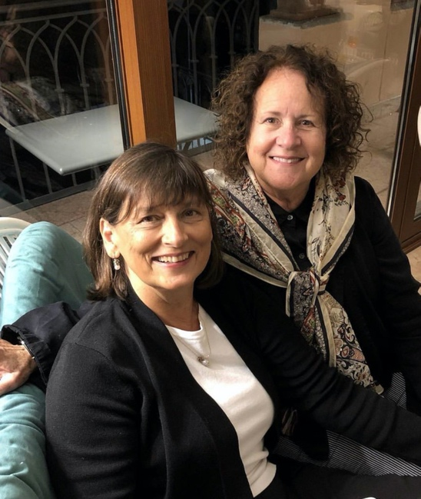
Linda & Kathryn
Photo: Greg Mehrten

